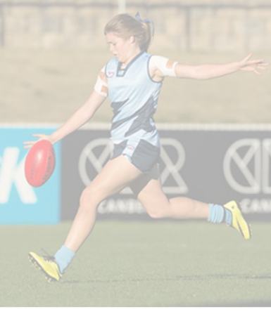
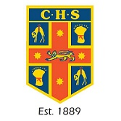

GREATER SYDNEY CHS GIRLS AFL TRIAL

Who: Trial is for U/15 Girls (Girls can be 15 and not turning 16 this year)
Where: Blacktown International Sports Park - Eastern Road Rooty Hill
When: April 11th from 10.30am to 2pm

Students will play a scratch match to determine selection. AFL appropriate gear, boots and mouth guards are required for all girls trialling.

Students are asked to fill in the attached form and return their registration via the details on the sheet (email or fax) by April 4th 2018.

Selected players will play in the NSW All Schools Australian Football Girls Championship to be held in Blacktown in June.

For further information, contact Michael Strappazzon via email at michael.strappazzon@det.nsw.edu.au

